**7. Decision Making**

Decision making is **anticipation of conditions** occurring while execution of the program and specifying actions taken according to the conditions.

Decision structures evaluate multiple expressions which produce **True** or **False** as outcome. You need to determine which action to take and which statements to execute if outcome is TRUE or FALSE otherwise.

Following is the general form of a typical decision making structure found in most of the programming languages −

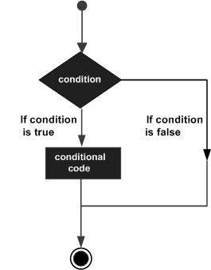

Python programming language assumes any **non-zero** and **non-None** values as **True**, and if it is either **zero** or **None**, then it is assumed as **False** value.

Python programming language provides following types of decision making statements. Click the following links to check their detail.

|  |  |
| --- | --- |
| **Sr.No.** | **Statement & Description** |
| 1 | [**if statements**](https://www.tutorialspoint.com/python/python_if_statement.htm)  **sum = 20+30 statement**  ***10+20* expresssion**  **10>20 expression**  An **if statement** consists of a boolean expression followed by one or more statements. |
| 2 | [**if...else statements**](https://www.tutorialspoint.com/python/python_if_else.htm) if elif elif elif else  An **if statement** can be followed by an optional **else statement**, which executes when the boolean expression is FALSE. |
| 3 | [**nested if statements**](https://www.tutorialspoint.com/python/nested_if_statements_in_python.htm)  You can use one **if** or **else if** statement inside another **if** or **else if** statement(s). |

Find Pass/ Fail.
mark = int(input())
if mark>=33:
print("Pass")
else:
print("Fail")
 

1.If Statement Syntax :

**if**(condition):

   statements

**Ex :**

a =15

**if**(!(a==10)):

**print** ("Welcome to Hello World")

Find Voter or Not Voter.
age = int(input())
if age>=18:
print("Voter")
else:
print("Not Voter")
 

Is a number Positive/ Negative/ Zero?
num = int(input())
if num>0:
print("Positive")
elif num<0:
print("Negative")
else:
p...

**2. if elif….else :**

Find Grade of Exam.
mark = int(input())
if mark>=80:
print("A+")
elif mark>=70:
print("A")
elif mark>=60:
print("B")
elif ...

**3. nested if else :**

a=10

**if** a>=20:

**print(** "Condition is True" )

**else**:

**if** a>=15:

**print(** "Checking second value" )

**else**:

**print(** "All Conditions are false")

**Assignment :**

1.Find grade of a student based on below requirement. Implement using if elif…..else logic

marks >= 80 => A+ , 60-70 => A, 50-60=> B, 40-50 => C, Below 40 FAIL

2.Find maximum number below. Implement using if elif…..else logic

a=10,b=30,c=20

3.Check whether given no. is positive or negative.

4.Check whether entered year is leap year or not.

5. Check an entered number is odd or even